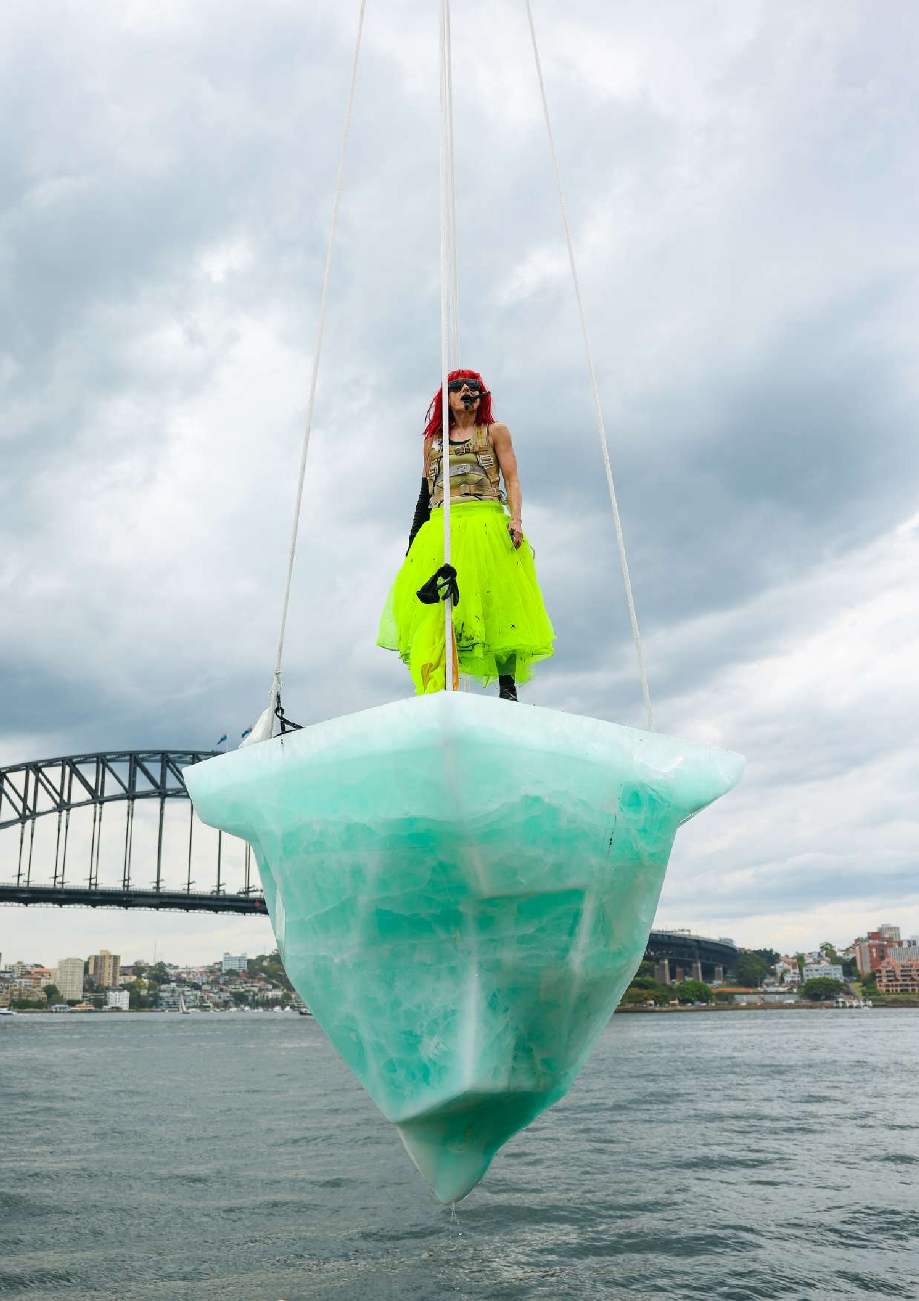SUSTAINABILITY PLAN

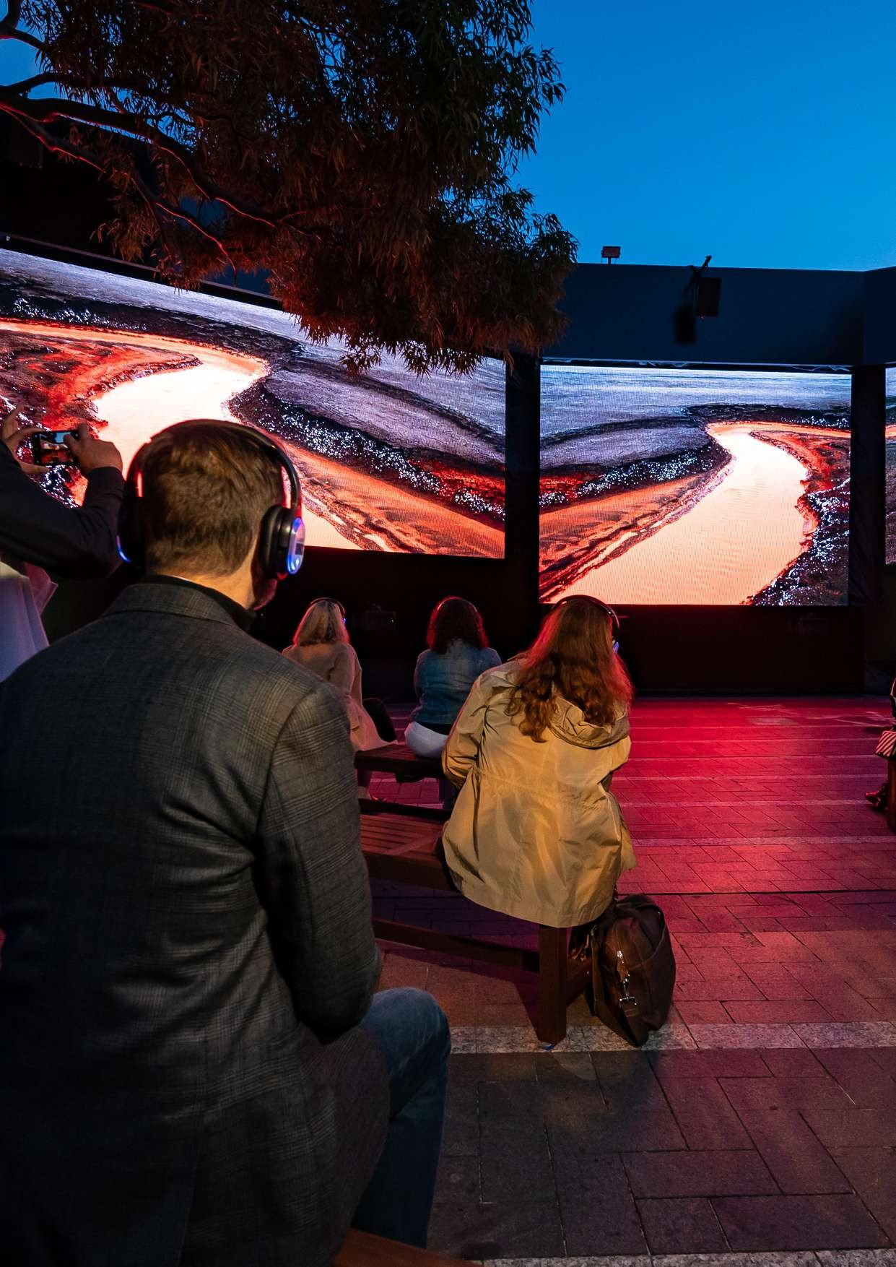In the Wake of Progress
2
Sydney Festival 2022

SUSTAINABILITY
PLAN

INTRODUCTION

Sydney Festival is Australia’s premier arts and cultural festival, and a highlight of the city’s vibrant annual events calendar. Each January the city-wide celebration of culture and creativity animates indoor and outdoor locations across Greater Sydney with theatre, music, dance, visual art and more.

We are proud of the role Sydney Festival plays in introducing audiences to new and established work from across the globe, yet we recognise that staging such productions, especially international work, comes at a cost to the environment which we both cherish and rely on to create world-class live events.

The performing arts benefit the community in ways beyond measure, so it is imperative that the industry adapts in order to deliver these benefits without exacting an unacceptable environmental toll.
Sydney Festival embraces the role it plays as a leading creative organisation in championing this evolution in operations, in raising awareness of climate change through the works we stage, and encouraging and empowering our local, national and international partners, staff, sponsors, vendors and audiences to adopt better practices.

We are striving to adopt greener ways of working by reducing our waste, using clean energy sources when available, partnering with sustainable companies and exploring the most impactful options for carbon offsetting that deliver a legitimate and evidence-based reduction of emissions.
At Sydney Festival we are committed to reducing our carbon footprint and doing our utmost to support global change towards a sustainable future.

We also commit to ongoing improvement of our sustainability practices: we will evaluate achievements and review priorities annually to ensure our actions are making a real difference

3

COVER IMAGE: THAW SYDNEY FESTIVAL 2022

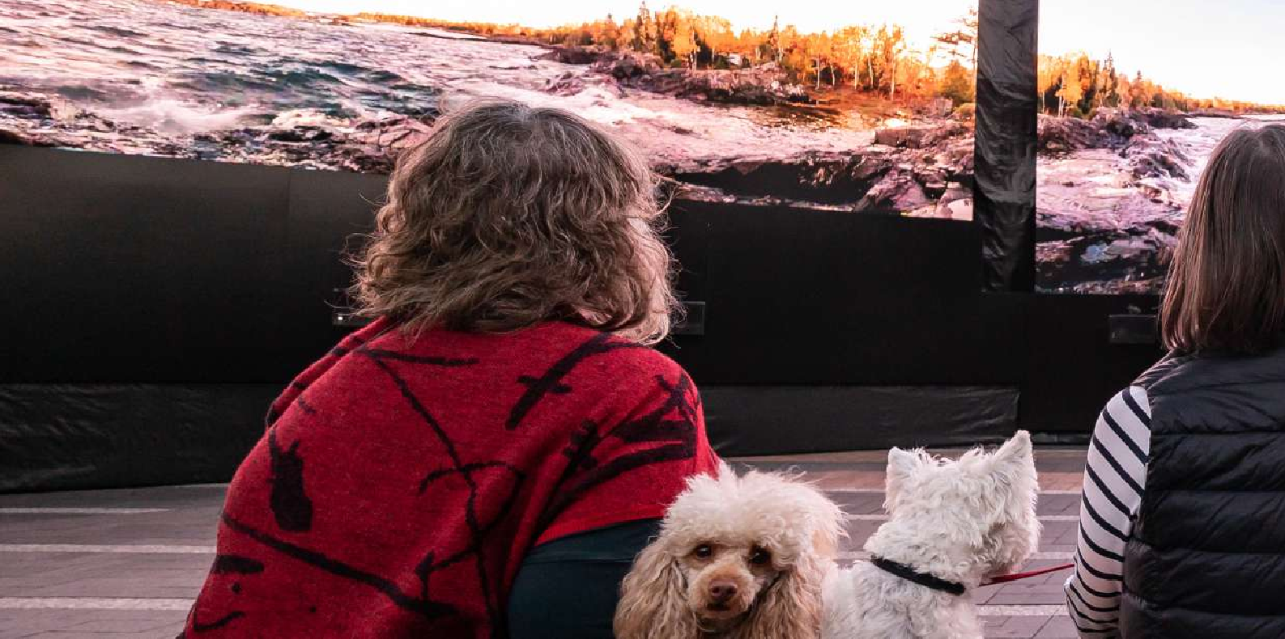

POLICY DEVELOPMENT

Sydney Festival strives to balance economic, environmental and social factors in a way that will ensure resource conservation and protection of the environment now and in the future. We will promote the efficient use of resources, reduce and prevent pollution and enhance biodiversity protection. Sydney Festival will communicate practical guidance to its stakeholders in applying an evidence-based approach to sustainability for all the activities we conduct, promote, produce or influence.

Sustainability policy development is currently underway. The scope of the Sydney Festival Sustainability and Environmental Management Strategy will include:
4

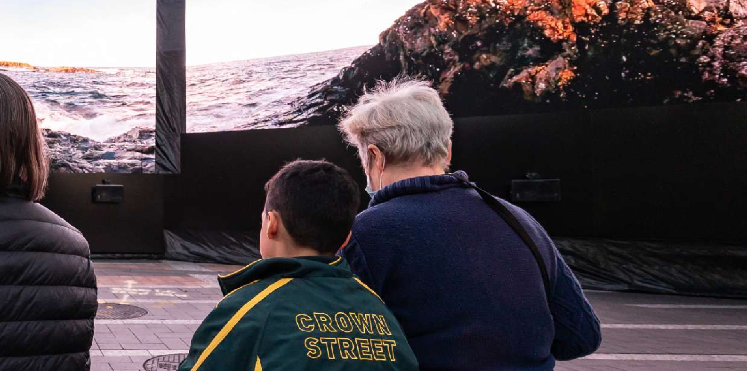Changing Processes
5
In the Wake of Progress
Sydney Festival 2022
Review and alter our operational activities where feasible to reduce greenhouse gas emissions and waste production.

Energy Efficiency
Improve our energy efficiency by reducing energy requirements of our operations.

Supply Chain Management
Introduce lower carbon products and services and develop partnerships with suppliers who foster sustainable development and support the reduction of greenhouse gas emissions and single-use plastics.

Renewable Energy
Purchase or generate green energy such as solar, geothermal or wind power wherever possible.

Fuel Switching
Reduce our Carbon Dioxide [CO2] / greenhouse emissions by switching to lower carbon content fuels where available and feasible.

Waste Management
Reduce refuse by eliminating single-use plastic packaging and selecting alternative disposal methods throughout our administration and operations.

Transport and Planning
Implement transport strategies which minimise climate impact (adopt new technology to reduce travel, encourage car sharing and maximize public transport).

Biodiversity Protection
Assess and consider ecological values and land- use aspects in our operational location selection.

Offsets
Where alternative efficiencies are not yet achievable, consider the purchase of greenhouse gas emission credits to compensate for our carbon footprint (by investing in emission reductions elsewhere).

Measurement and Targets
Measure our carbon footprint in order to set and achieve quantitative targets/outcomes that
reduce our environmental impact over a defined period of time.


A Bee Story
Sydney Festival 2021

OFFICE

SUSTAINABILITY
PLAN

The year-round Sydney Festival office at The Rocks in Sydney falls within the scope of our vision for a Sustainable Sydney Festival. We aim to review the operating and procurement practices of the office to ensure the most sustainable choices and practices possible.

OUR GOALS:
- Sustainably source stationery, kitchen products and catering.
- Switch the office power tariff to GreenPower (100%) and measure energy consumption.
- Review efficiency of equipment, energy saving modes, lighting and desktop switch-off initiatives.
- Scrutinise our waste and recycling systems and ensure measurement of volumes.
- Monitor and report business travel and consider offsetting for flights.
- Manage spare office space during off season.

7

SUSTAINABILITY PLAN
POWER

The potential impacts of power use by Sydney Festival include the consumption of fossil fuels in energy production, greenhouse gasses emitted, and creation of localised pollution from mobile generators. Power is required for stage sound, lighting and visuals, site offices and equipment, food stallholders, bars and site lighting in outdoor events, for
venue operation of indoor events, and for year-round office activities based at The Rocks, Sydney. Power for Sydney Festival is supplied through mains electricity and by mobile generators.

OUR GOALS:
- Reduce total power use.
- Maximise use of renewable energy.
- Reduce greenhouse gas emissions.
- Develop measurement systems to report on power use by events and venues.

8

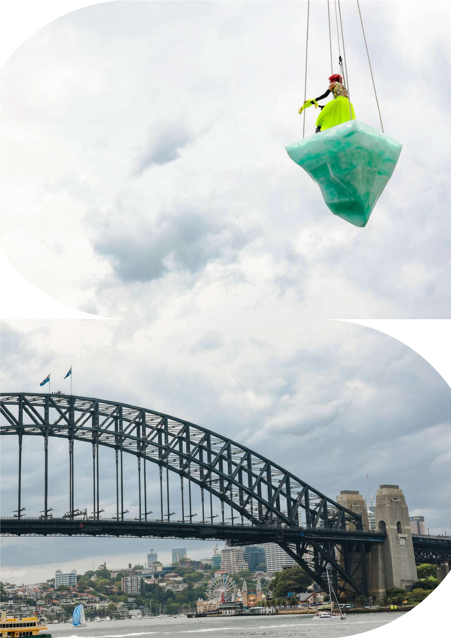THAW
Sydney Festival 2022

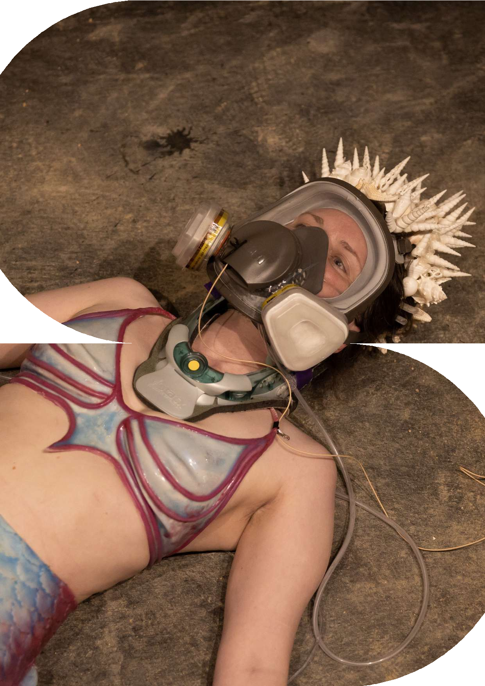The Mermaid
Sydney Festival 2020

WASTE

SUSTAINABILITY
PLAN

We understand that excessive waste is a result of failing to value resources. The pressures of creating new materials, particularly to market our activities each year, create unnecessary waste. At our events we work towards waste logistics being a resource recovery exercise. Planning what will be procured and foreseeing the end-of-life of each item ensures resources are recovered through recycling, composting or salvage/re-purposing.

We are continually assessing and improving our processes to ensure a more sustainable approach in managing and reducing waste created through food and beverage consumption at Festival venues.

OUR GOALS:
- Reduce total waste production.
- Maximise diversion from landfill through the recovery of waste resources by recycling, repurposing and composting.
- Engage venues to support Sydney Festival waste goals.
- Develop measurement systems to report on waste production at venues.

11

SUSTAINABILITY PLAN
TRANSPORT

Attendee and artist travel are large contributors of GHG emissions for Sydney Festival. Additionally, freighting of equipment, infrastructure and waste contribute to the overall GHG emissions impact of the event.

OUR GOALS:
- Promote active transport.
- Work with the City of Sydney to align with their cycling strategy.
- Promote public transport by prioritising precincts with good public transport connections.
- Schedule performances/events within public transport timetables.
- Use low and/or zero emission vehicles.
- Use B20 in diesel plant equipment and site vehicles.
- Encourage performers and crew to offset flights when travelling for the Festival.

12

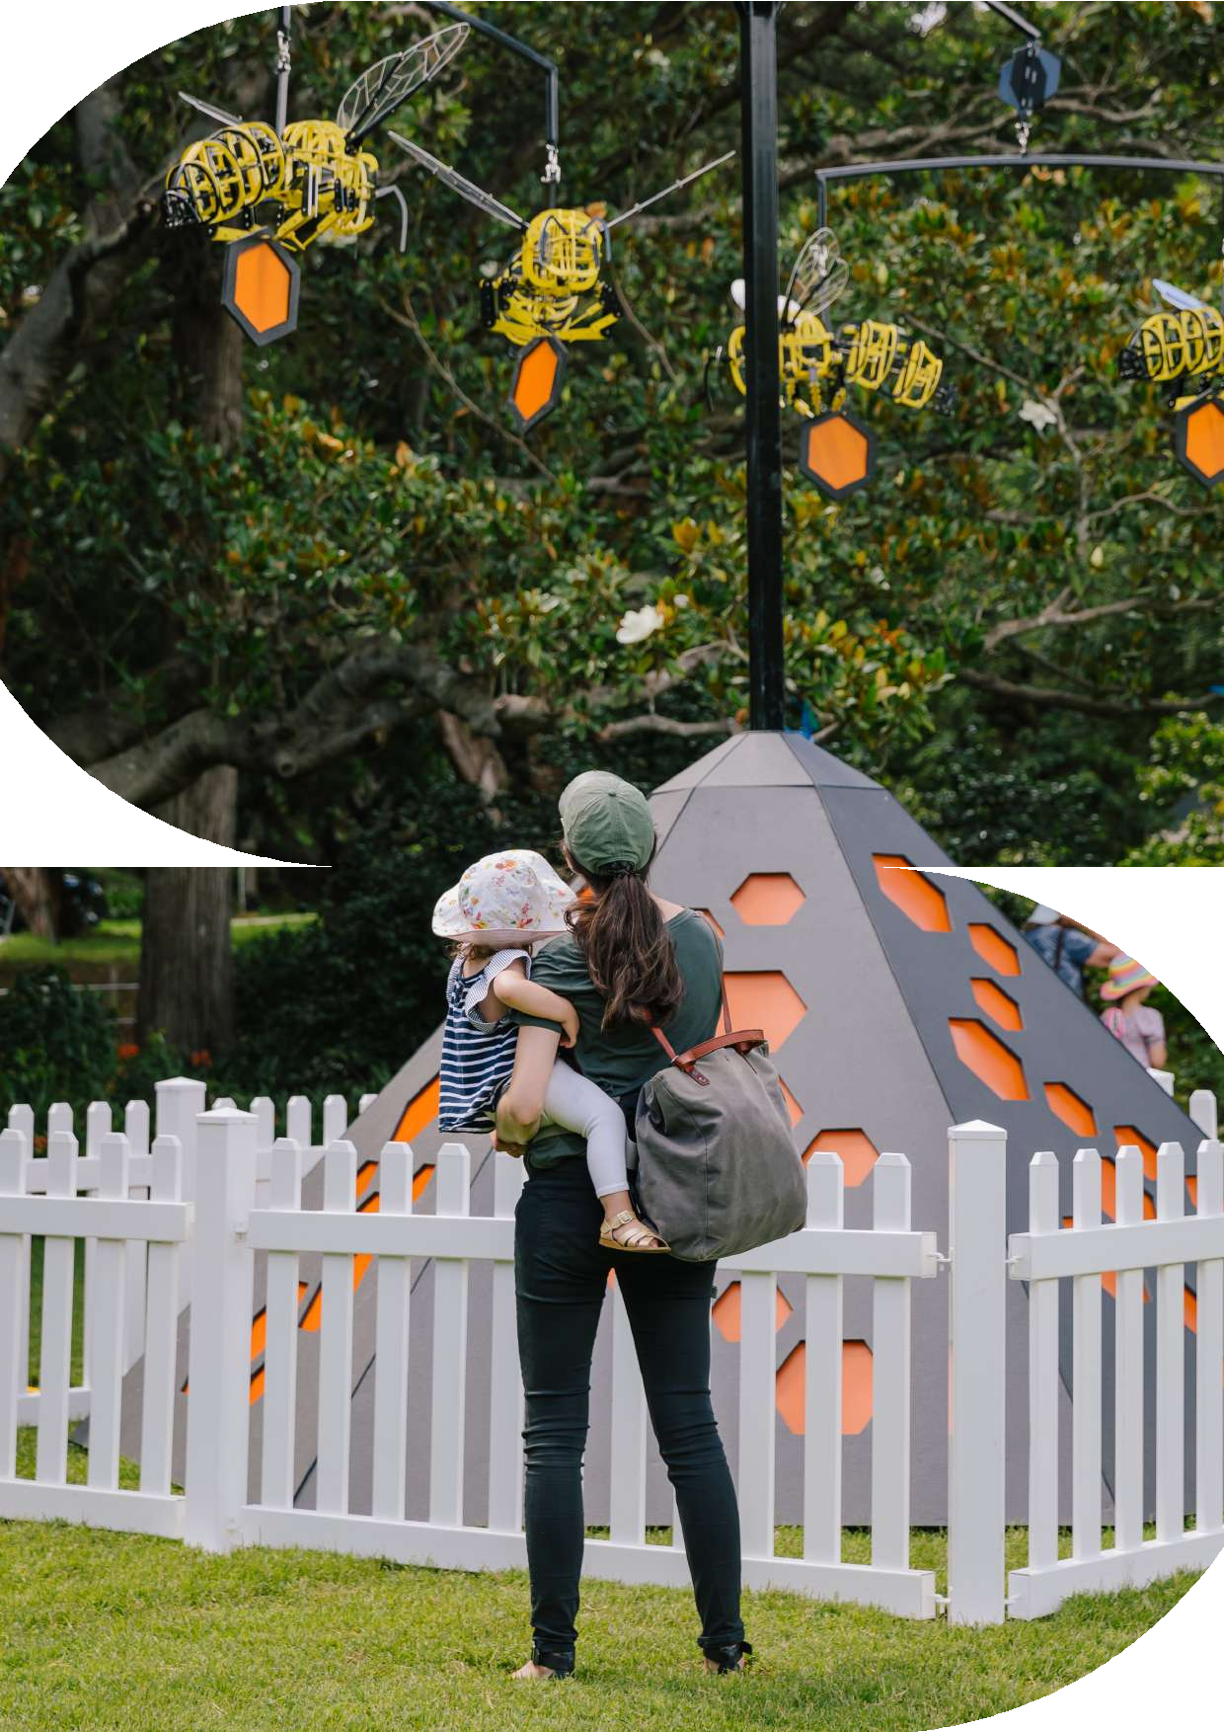Hive Mind
Sydney Festival 2021

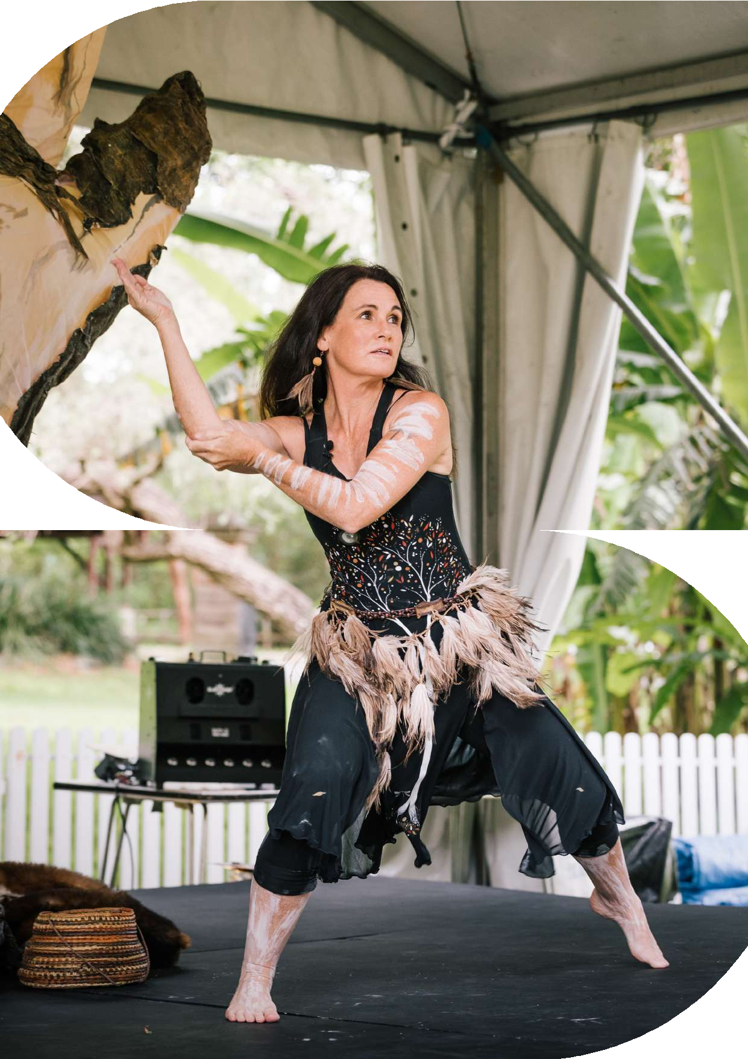Under The Mandhan
Sydney Festival 2021

SUSTAINABILITY
PLAN
PROCUREMENT

Purchase decisions are made every day in the pre-production phase of event planning, and the right choices need to be made to manage potential sustainability impacts of procurement.

Sydney Festival’s ambition is to identify the most sustainable sourcing options. This will be achieved through supply chain management and focused sourcing of sustainable materials and supplies. We will develop a Sustainable Procurement Policy which will detail specific requirements and preferences.

Venues, performers, staff, crew, contractors, food stallholders, sponsors, and service providers are made aware of Sydney Festival’s sustainability commitments. The supply chain and venues are encouraged to have their own Sustainability Policy where applicable. Those who undertake event activities and indirectly procure on behalf of Sydney Festival are encouraged to understand the impacts of their procurement activities and to take steps to make the most sustainable choices to help meet Sydney Festival’s sustainability goals.

OUR GOALS:
- Purchase only what is needed in the quantities required.
- Store and reuse rather than discarding after a single use.
- Procure products and services locally to support the local economy and reduce transport impacts.
- If local products are unavailable, procure Australian-manufactured products made from Australian materials.
- Use local, organic, or seasonal produce where possible.
- Choose sustainably sourced seafood, meat, eggs, and dairy products.
- Choose products, materials, supplies and equipment with optimal sustainability credentials

15

SUSTAINABILITY PLAN
COMMUNICATIONS

Communications and engagement of stakeholders with sustainability initiatives at Sydney Festival is critical to our performance success.

Sustainability is a fluid and ongoing conversation within the Sydney Festival team and will continue to be a discussion point on our internal agenda.

OUR GOALS:
- Include sustainability-related content in our programming and audience interactions where possible and relevant.
- Collaborate with existing local sustainability programs and campaigns
(government and non-government) where they mesh with our activities and event logistics.

16


A Ghost in My Suitcase
Sydney Festival 2019

SYDNEY FESTIVAL
Level 5, 10 Hickson Road The Rocks, NSW 2000 Sydney, Australia

T: 02 8248 6500
E : mail@sydneyfestival.org.au

sydneyfestival.org.au

